PYTHON LAB ASSIGNMENT 1

NAME OF STUDENT: SANSKAR KHANDELWAL

CLASS: CB-2

CLASS ROLLNO: 42

UNIVERSITY ROLL NO: GLA2023-05040009

SUBMITTED TO: M.R. ANIK ACHARJEE

PROBLEM STATEMENT: Education Loan Calculator using Python

You are tasked with creating a Python program that calculates the monthly payment for an education loan based on the principal amount, annual interest rate, and the loan term (in years) provided by the user.

Input code:

# Input of Principal Amount

principal = eval(input("Enter Principal amount (p) : $"))

# Input of Annual Interest rate

rate = float(input("Enter Annual Interest rate (r) "))

# Input of Loan term

n = float(input("Enter Loan term in years (n) "))

# Conversion of Annual interest rate into Monthly interest rate

r = (rate/12)/100

# Conversion of loan terms in years into total number of payment

n = n*12

# Formula to calculate Monthly payment

M = (principal * r * ((1+r)**n))/(((1+r)**n)-1)

# Output

print("Monthly payment:"," %.2f"%M,"Dollars")

code output:

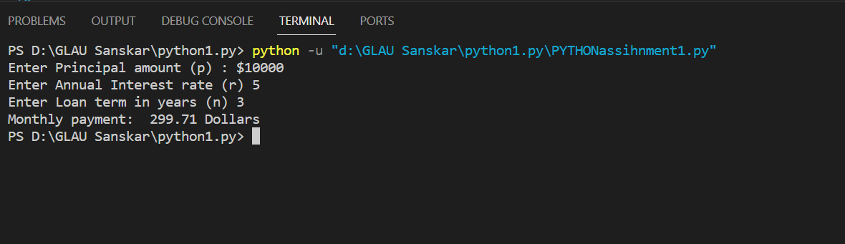

THANKYOU